CUSTOMER CHURN PREDICTION IN TELECOM INDUSTRY
(Machine Learning Based Customer Retention System)
Scope and Limitations
Department of Computer Science and Engineering, TKR College of Engineering and Technology (Autonomous)
Batch A14 (CSE-A) · Academic year [ACADEMIC YEAR]
Table 1: Project team
S.No. | Student name | Roll number
1 | ANANTULA SAI NIKHILA SRAVANI | 23K91A0512
2 | AVULA ANUDEEP | 23K91A0518
3 | B SANDEEP | 24K915A0503
4 | DARAGANI VINOD KUMAR | 23K91A0558

Project guide: B. SRIKANTH, Assistant Professor, Department of CSE
Chapter and section numbers quoted in the text (for example Section 6.6 or Chapter 8) refer to the full project report, 17.Final Document. Figures and tables in this document are numbered from 1.

1. SCOPE
In scope. The system covers the following, all of which are implemented and tested:
• Loading a customer CSV or generating a sample; detection of the target and ID columns; data-quality report; cleaning.
• Exploratory analysis of churn by attribute, with filters.
• Training and comparison of Logistic Regression, Decision Tree and Random Forest (and optionally Gradient Boosting and Histogram Gradient Boosting) with class weights, SMOTE or no handling.
• Evaluation on five metrics, confusion matrices and ROC and precision-recall curves; model selection on a chosen metric; saving and restoring the active model.
• Scoring of every customer, four risk bands with validated, editable thresholds, and a dashboard.
• Global and local explanation, what-if analysis, rule-based retention actions.
• Batch scoring of a new CSV with a schema check, and a drift screen.
• Two interfaces (Streamlit and a React web interface over a FastAPI service) with a demo login.
Out of scope.
• Collection or purchase of real operator data; the project's results rest on a synthetic sample.
• Real-time scoring from live billing or network events.
• A production database, multi-user operation, roles, auditing, and production-grade authentication.
• Integration with a CRM or campaign system.
• Measurement of the financial effect of retention campaigns.
• Deep-learning and external gradient-boosting libraries, LIME, and the unified perturbation explainer of the base paper.

2. ASSUMPTIONS
• The customer table has one row per customer and a binary churn label for training.
• Column names follow the 21-column Telco schema; other schemas run through the generic pipeline but the retention rules use only the Telco field names.
• One analyst uses the system at a time; state is held in memory.
• A churn probability is a model score used to rank customers, not a calibrated chance of leaving.
• The synthetic data stand in for an operator's data so that the pipeline can be demonstrated and tested.

3. LIMITATIONS
Table 2: Limitations and their consequences
Limitation | Consequence | Evidence
Synthetic data | No claim about real-world accuracy | Generated by src/sample_data.py; churn follows a latent score plus noise
Small test set | Single-split metrics are noisy | 200 rows, 53 churners; sd 0.03-0.10 across folds and splits
Moderate ranking ability | Predictions are useful for prioritising, not for certainty | ROC-AUC 0.722; F1 0.486; lift about 2 in the top 20%
Uncalibrated probabilities | Risk bands are rankings, not chances | Brier 0.213 against 0.195 for a constant predictor
Version-sensitive tree ensembles | The Random Forest number depends on the scikit-learn version | F1 0.4724 (scikit-learn 1.9.1) against 0.4815 (1.5.0)
No SHAP result | Explanations are approximations | import shap fails in the environment; fallbacks used
Rule-based advice | Effect on churn unknown | Rules written by the team; no campaign data
In-memory state | Dataset and comparison are lost on restart; one user | AppState design; only the active model is persisted
Demo login | Not suitable for real customer data | One shared account in .env
Limited testing | No load, security, usability or multi-browser evidence | Section 7.7

Two of the limitations can be seen directly in the measurements. The first figure shows how far the headline split can differ from cross-validation and from repeated splits; the second shows that the predicted probabilities are above the observed churn rate in every bin.
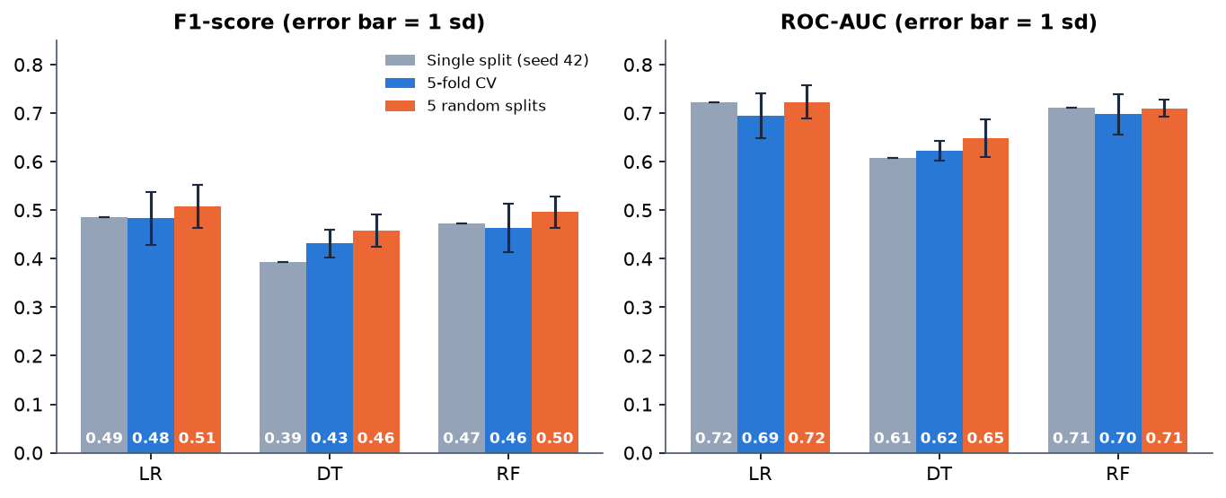
Figure 1: F1-score and ROC-AUC on the single split, in cross-validation and on five splits (error bars: one standard deviation)
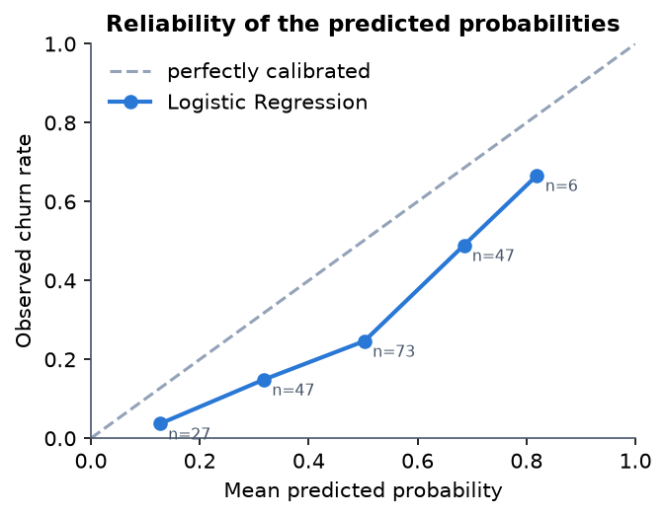
Figure 2: Reliability of the predicted probabilities (Logistic Regression, test split)

4. WHAT WAS NOT MEASURED
The following were not measured and are therefore not claimed anywhere in the project documents:
• Performance on real customer data or on the real public Telco file.
• The business value or uplift of any retention action.
• Calibration after recalibration, and cost-sensitive (profit) performance.
• SHAP-based explanations and any comparison of the built-in explanations with SHAP or LIME.
• Behaviour with several simultaneous users or very large files.
• Usability with real retention analysts.

